### **GDD of Nguyen Hong Huyen Anh**

### **s31879**

## **1. Story background**

Brief lore, setting, and key events shaping the game's world.

* In the city/kingdom of ___, their world is one of beauty and serenity, with a rich culture that includes festivals, art, and music. The civilian lived in absolute bliss and florious in every aspect of life but the irony is not lost on them. Behind this facade of joy, lies a dark truth. The core of ___s’ prosperity is a group of children, confined to small, filthy living conditions, who suffer immense physical and emotional abuse. A group of children is locked away from the city’s citizens, and its misery is the essential foundation upon which the happiness of the entire society is built.
* Key events:
* The pact of prosperity: A long forgotten tragedy that almost wiped out the city/kingdom. In a desperate attempt to save it, the people had made a deal with an entity, offering it the misery of a group of children in exchange for its people's eternal happiness.
* The present: Every decade, a new child is made to be the sacrifice. The previous victim, who is broken beyond repair, will be exiled from the kingdom, left to fend for themself.

## **2. Brief description of the multimedia application**

Short summary of the application’s purpose, genre, and main features.

* Application’s purpose: The game is a narrative-driven 3D adventure that explores themes of moral dilemmas, sacrifice, and the complexity of human choices. The player takes on the role of a character navigating a world where happiness is built upon the suffering of others. The main purpose of the game is to engage the player in critical decision-making, exploration, and interaction with NPCs, while uncovering the dark secrets of the world.
* Genre: Narrative-driven puzzle adventure with horror/thriller elements
* Main features:
* NPCs Interactions & Conversation
* Part-time job mini game(still thinking)(probably not)
* Exploration & Investigation
* Puzzle solving, choices and consequences.
* Companion AI
* Inventory & diaries
* 3D exploration

## **3. Art style and orientation**

Description of the visual aesthetics, including inspirations, color schemes, graphical fidelity (realistic, stylized, pixel art, etc.), and mood/tone of the multimedia application.

Orientation details such as 2D vs. 3D, top-down, side-scrolling, isometric, or first/third-person perspective.

Visual aesthetics: 3D stylized semi-realism

Color scheme:

On the surface: warm & vibrant

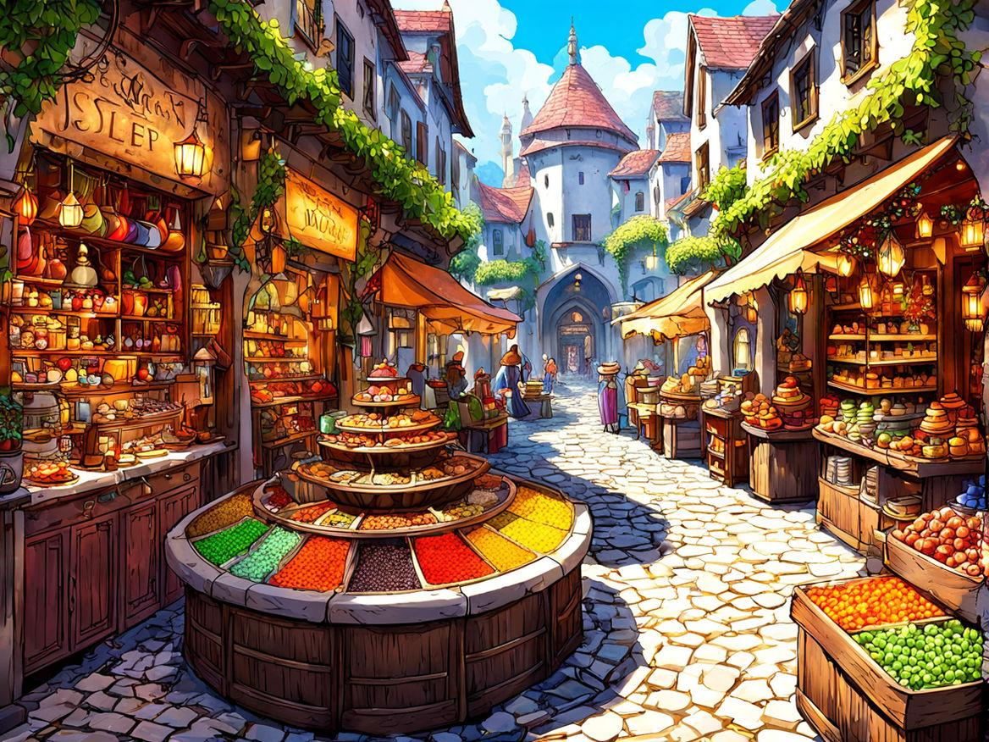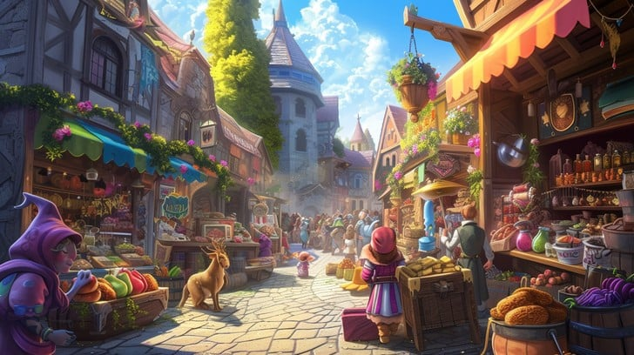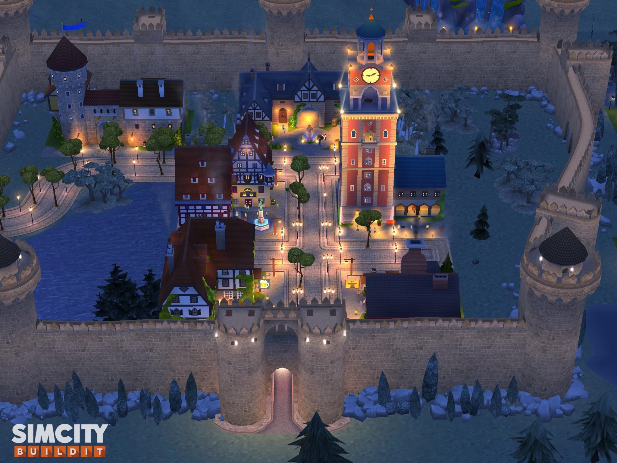

Underground: Muted & Eerie

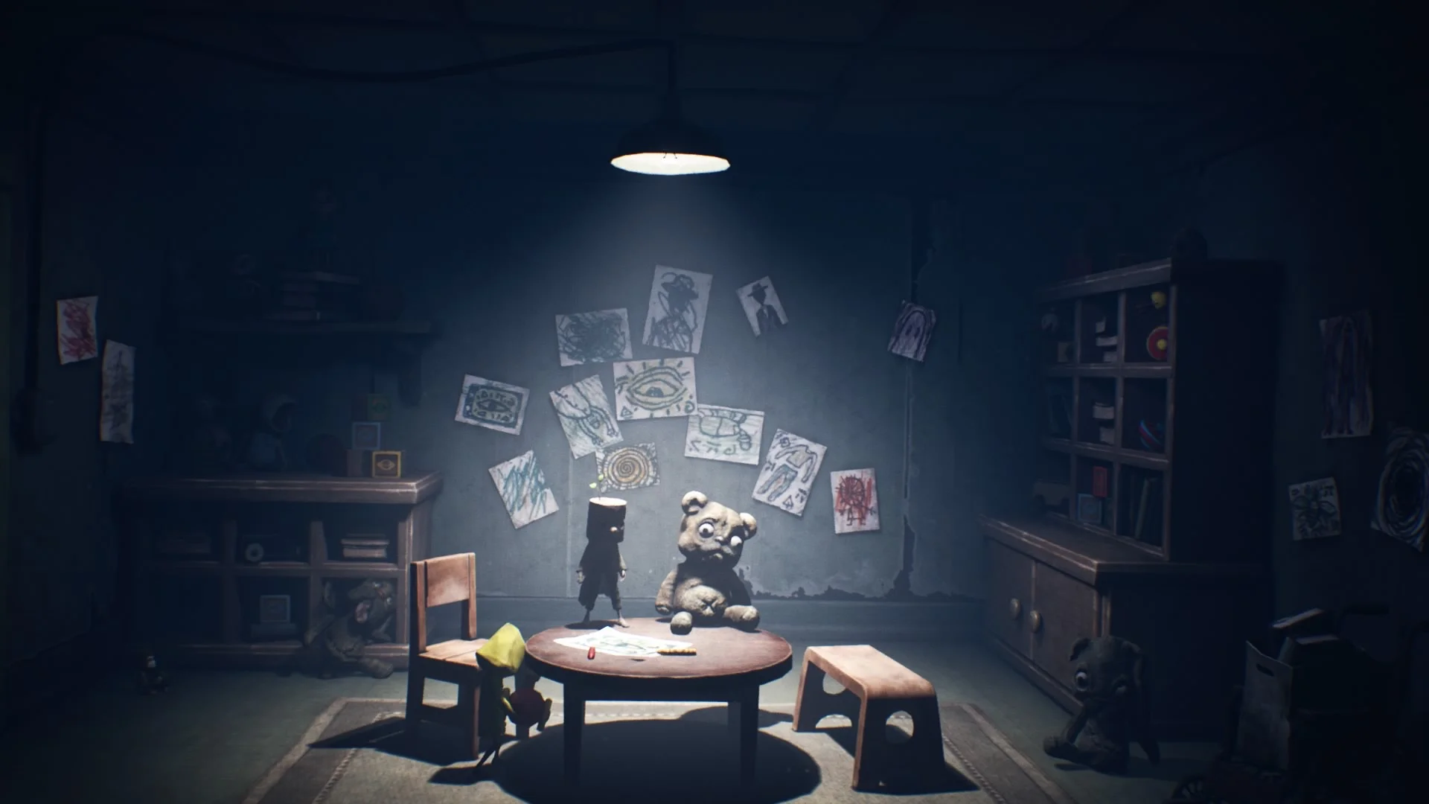

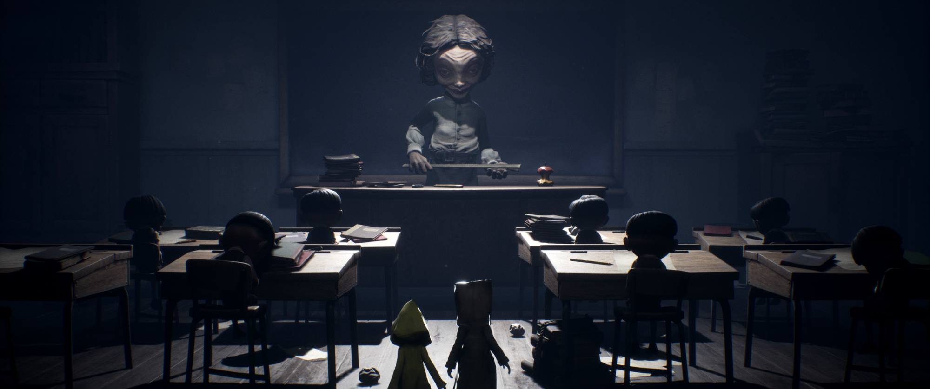

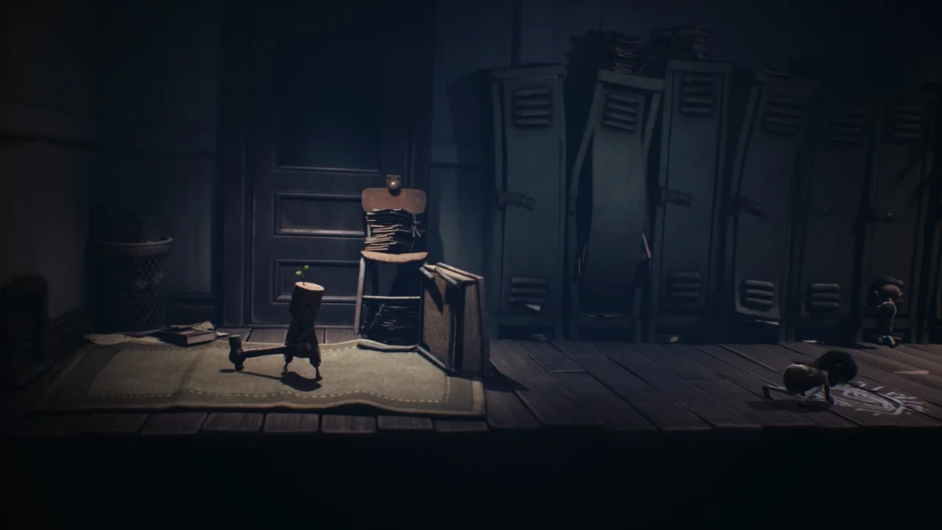

Perspective: third person

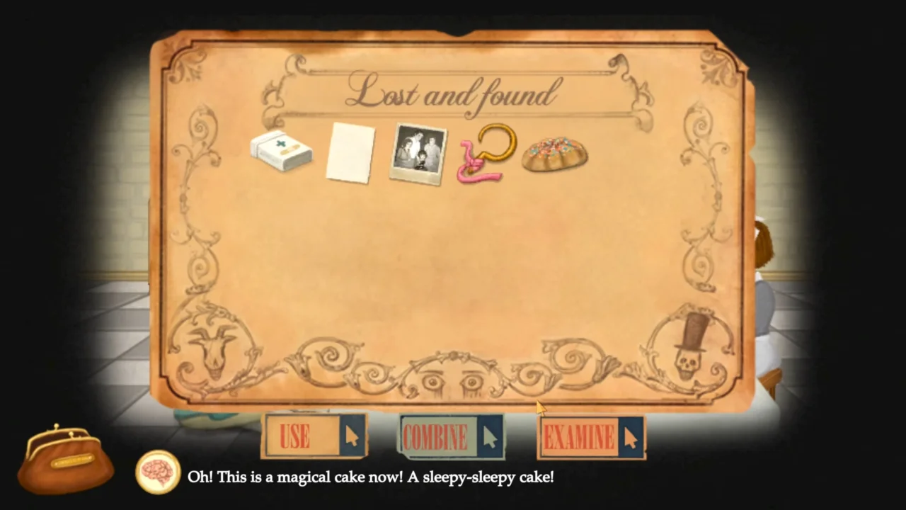

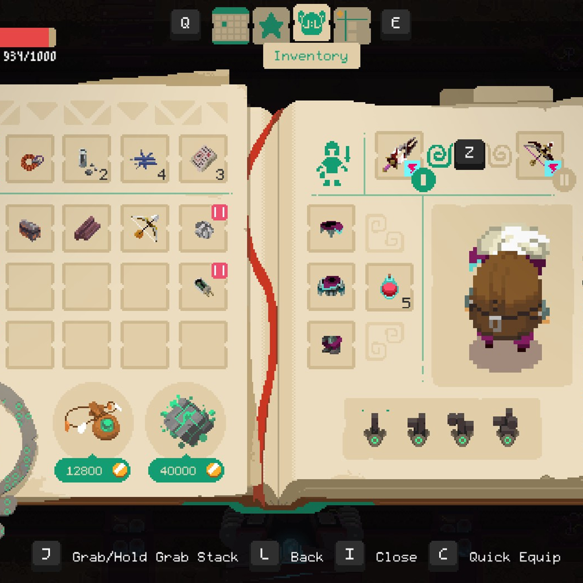

## **4. Core gameplay loop**

* Exploration & Environmental Interaction (Core Loop): Player can freely explore the city above and the underground( for a while at the beginning)
* The world is semi-open, with multiple paths, hidden areas, and interactable objects.
* Repetitive engagement mechanics:
* Opening doors, searching drawers, interacting with objects(some will trigger events, diary entries, hidden stories,...)
* Climbing, crouching and sneaking
* Inspecting object in 3D to find clues(turning object over to reveal hidden writing)

## **5. Technologies used and why**

* Unreal Engine 5: real-time rendering, physics simulation, and AI capabilities. Built for high quality 3d games,..Nanite & Lumen for high-fidelity environments and realistic lighting.
* Unity: chosen for its flexibility, and strong support and easier to use. Allows for efficient prototyping, a wide range of ready to use assets, and support 3d environments, dialogue systems and puzzle mechanics,..
* C#: more beginner-friendly, well-documented, and widely use in Unity development
* C++: faster and more efficient, more flexibility to modify unreal engine code for unique mechanics.
* Other Tools:
* Blender (3D modeling, character animation).
* Substance Painter (Texturing, material creation).
* Quixel Megascans (High-quality environmental assets).

## **6. Main functionalities**

* Exploration & Navigation
* Third-person movement with environmental traversal.
* Interactive world objects (doors, books, secret tunnels).
* Dynamic NPC Interactions & Branching Dialogue
* NPCs react to player choices over time.
* Unlock dialogue with NPCs, discovering information,..
* Puzzle-Solving & Investigation System
* Item-based puzzles requiring object examination.
* Environmental puzzles unlocking hidden paths.
* Stealth & Threat Avoidance
* Hiding under furniture, behind walls.
* Distraction mechanics (throwing objects, knocking on walls).
* AI Companion System**(optional)**
* The child helps solve puzzles, sneaks into small spaces, and follow the player.

## **7. Other Functionalities**

* Diary & Note System
* Automatically records discoveries, clues, and past conversations.
* Inventory System
* 3D object examination (rotate, combine, or use).
* Day/Night Cycle (City Above Ground)
* Time-based NPC schedules for realistic immersion.
* Achievements & Player Progression
* Secret endings, hidden collectibles that expand lore.

## **8. Graphical interfaces (GUI and menu prototype)**

Overview of user interface components, including HUD, menus, and navigation elements.

The player will have an inventory and diary that will update as we progress with the story, show who the player interacted with, what we have discovered,...

* HUD (Minimalist Approach)

Visual Feedback Instead of Overlays (immersive UI)

* No permanent HUD—interaction cues appear naturally (e.g., icons near objects).
* Contextual prompts (e.g., “Hold [E] to examine”).
* Companion status indicated by animations rather than UI bars.
* Menu System

+ Diary Menu: Player flips through an in-game physical journal.

+ Inventory Menu: 3D bag UI where objects can be examined.

+ Settings & Save Menu: Accessible via an in-world desk or book.

## **9. List of assets**

(not a concrete list 🫠)

3D Models

+ Environments: Utopian city, underground slums, secret tunnels.

+ Characters: Player character, child companion, NPCs, caretaker.

+ Props: Books, lanterns, tools, clothing, locked doors.

Textures & Materials

+ Environment Textures: High-quality materials for stone, wood, rusted metal, decayed walls, and opulent city designs.

+ Character Textures: Realistic fabric for clothing, skin details, and dirt/grime for underground children.

+ Prop Textures: Books, old papers with worn ink, lantern glass, bloodstains, etc.

Animations

+ Player Character Animations:

+ Walking, running, crouching, climbing.

+ Stealth animations: Slow movement, peeking, hiding under objects.

+ Interaction animations (opening doors, picking up items, flipping through diary).

+ Child Companion Animations:

+ Idle states (shivering, looking around nervously).

+ Following the player, sneaking, crawling through tight spaces.

+ Emotional reactions (scared, curious, hesitant).

+ NPC Animations:

+ City NPCs: Relaxed, chatting, working.

+ Underground Children: Weak movements, huddling, coughing.

+ Caretaker: Calm but unsettling movements, slow head turns, stiff posture.

Sounds & Music

+ Ambient Sounds:

+ City above: Market chatter, distant music, footsteps on cobblestone.

+ Underground: Dripping water, echoes, muffled crying.

+ Character Sounds:

+ Player & child’s breathing, footsteps, whispering.

+ Caretaker’s unsettling hums or footsteps approaching.

+ Music:

+ Soft orchestral melodies in the city.

+ Distorted lullabies in the underground for tension.

+ Dynamic sound shifts when danger is near.

UI Elements & Effects

+ Diary UI: Handwritten notes, sketches appearing dynamically.

+ Inventory UI: Items appearing as 3D models to inspect.

+ Subtle HUD effects:

+ Heartbeat audio cue when in danger.

+ Subtle color shifts based on morality choices.